**Home Page**

1. Same As Website (Header)
2. About Us (Same)
3. Graphic service we offer (Minimalist logo design, Trucking logo design, Food Logo design, Neon Logo Design, Mascot Logo Design, Business card design, Flyer/Brochure Design, Office Stationery Design)
4. YouTube Monetization Service
5. Website Design Services
6. Digital Marketing Services (Social Media Marketing, Search Engine Optimization (SEO))
7. Our Working Process (Same)
8. WhatsApp And Messenger Button
9. Footer depends on you

**About Us**

Same/Similar/As you liked

**Services**

1. Logo & Branding (Minimalist logo design, Trucking logo design, Food Logo design, Neon Logo Design, Mascot Logo Design, Business card design, Flyer/Brochure Design, Office Stationery Design) YouTube Monetization Service, Website Design Services, Digital Marketing Services (Social Media Marketing, Search Engine Optimization (SEO))

When Click Any Services Open Page

In New Page Some Data about services And Service-related Samples Show 10 to 15

Like in above example

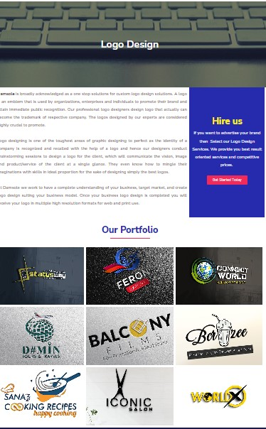

**Pricing Plan**

Logo & Branding (Minimalist logo Pricing, Trucking logo Pricing, Food Logo Pricing, Neon Logo Pricing, Mascot Logo Pricing, Business card Pricing, Flyer/Brochure Pricing, Office Stationery Pricing)

YouTube Monetization Service Pricing

Website Design Services Pricing,

Digital Marketing Services (Facebook/Instagram Marketing Pricing, SEO Plan & Pricing)

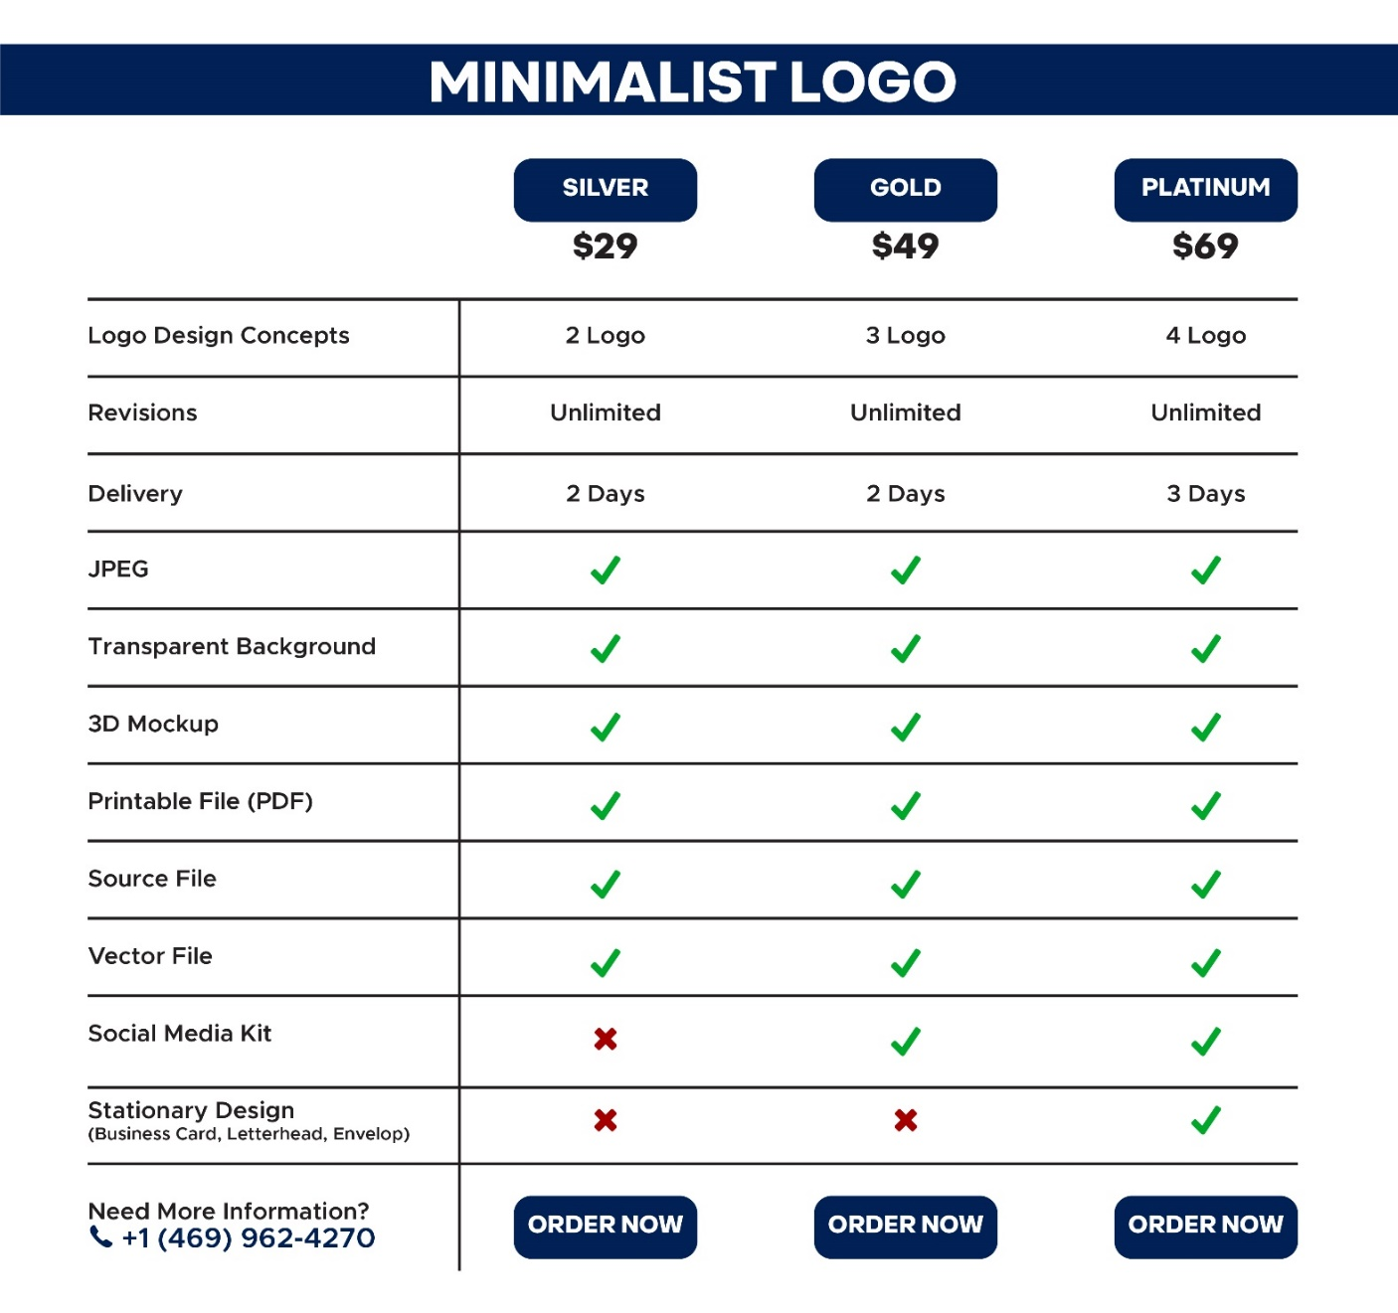

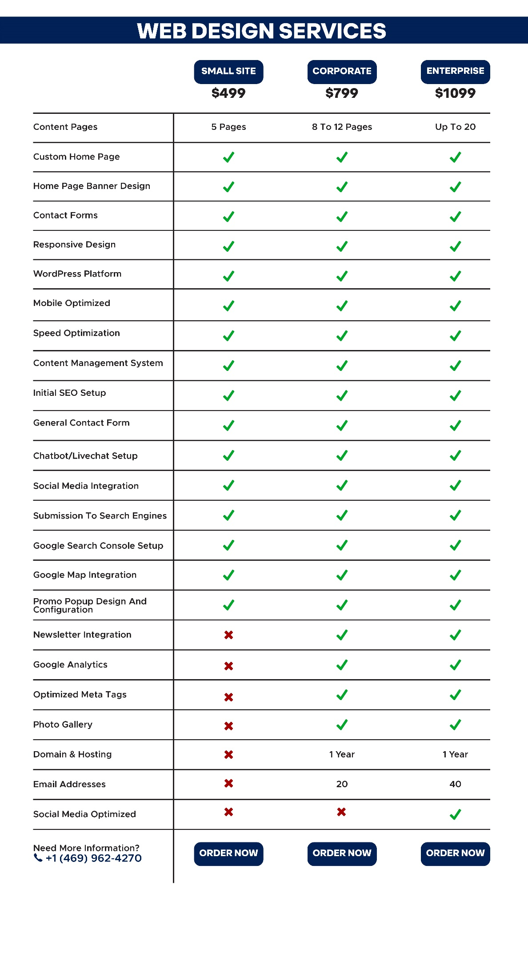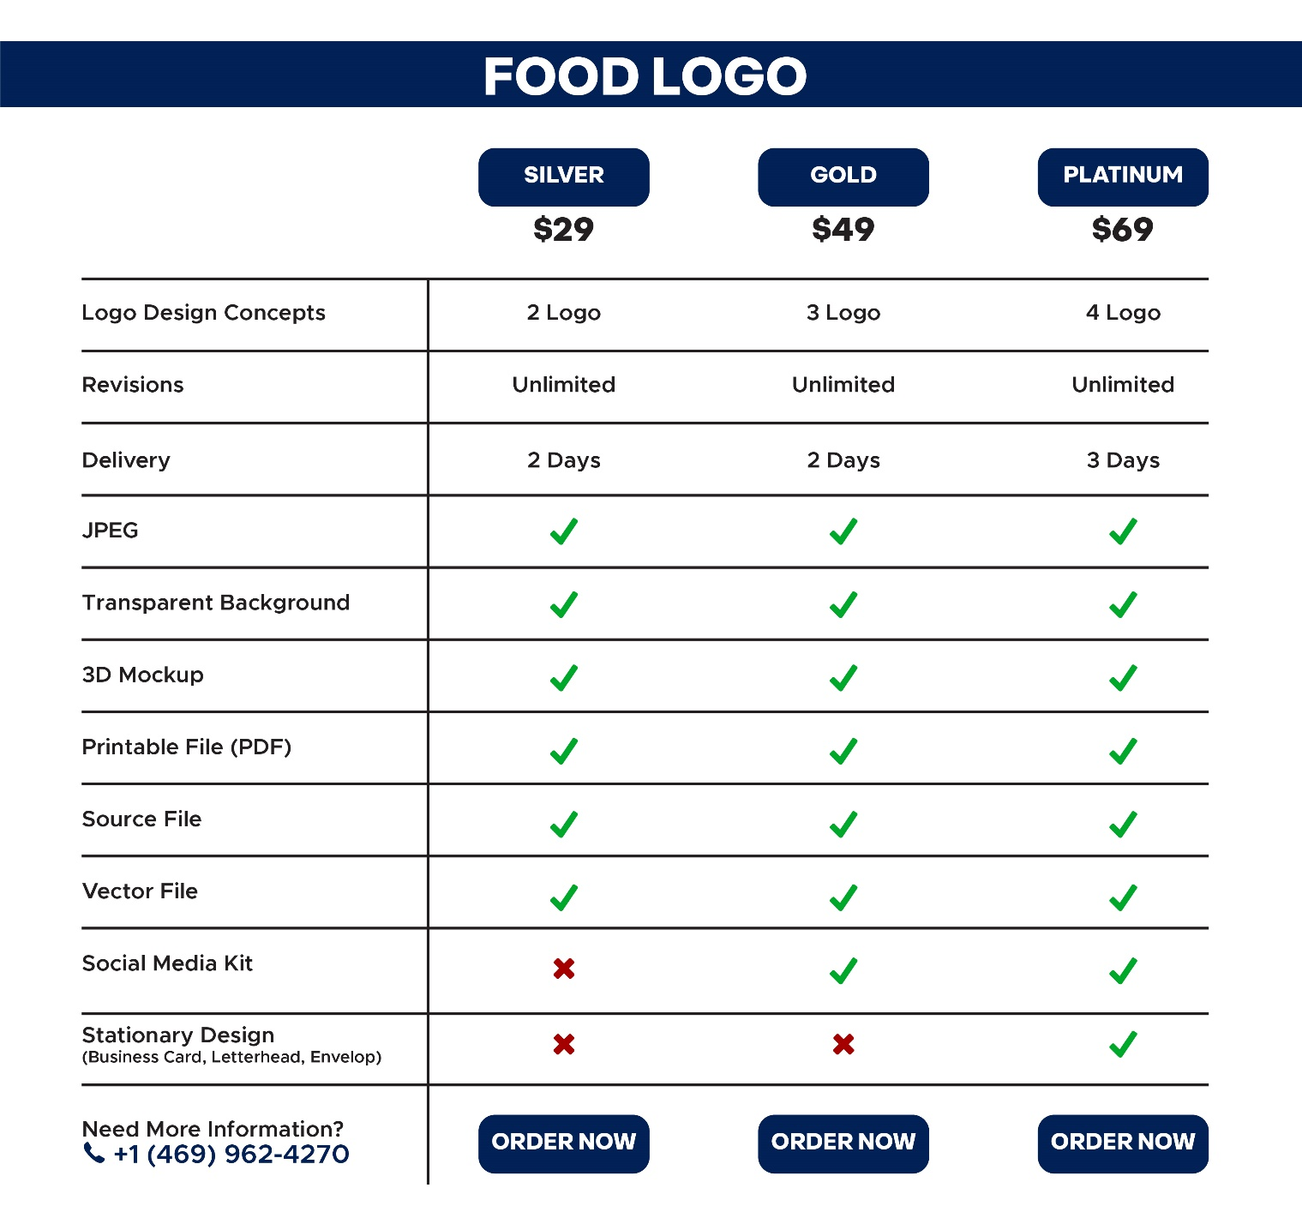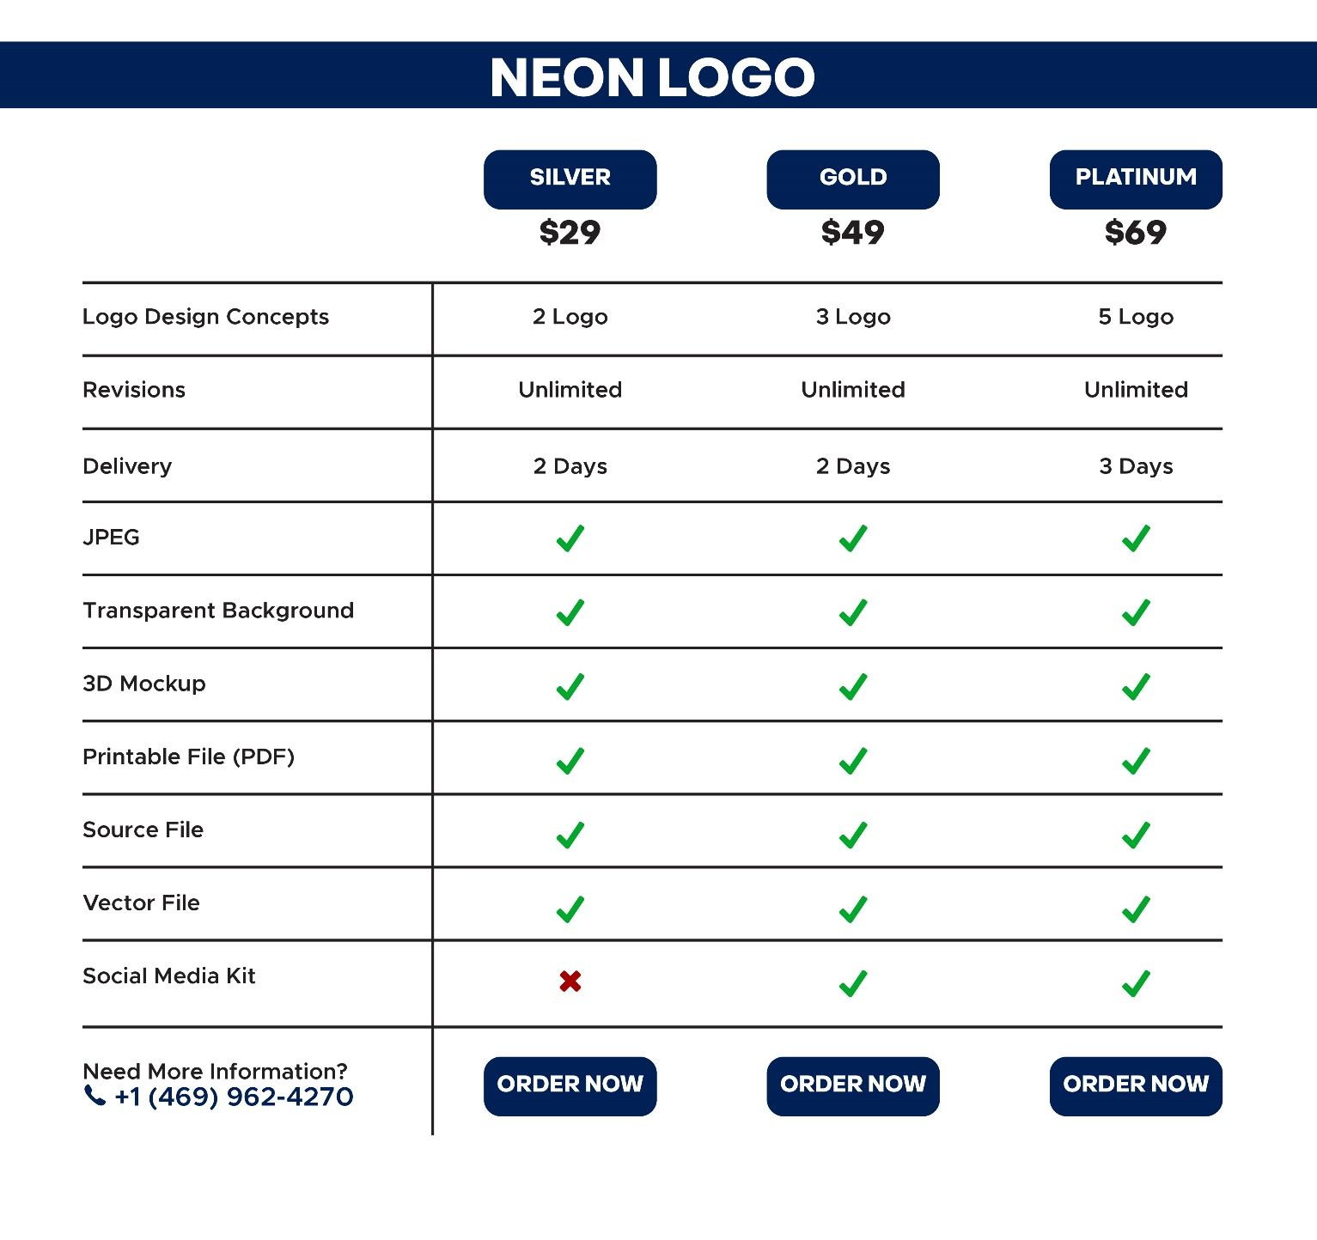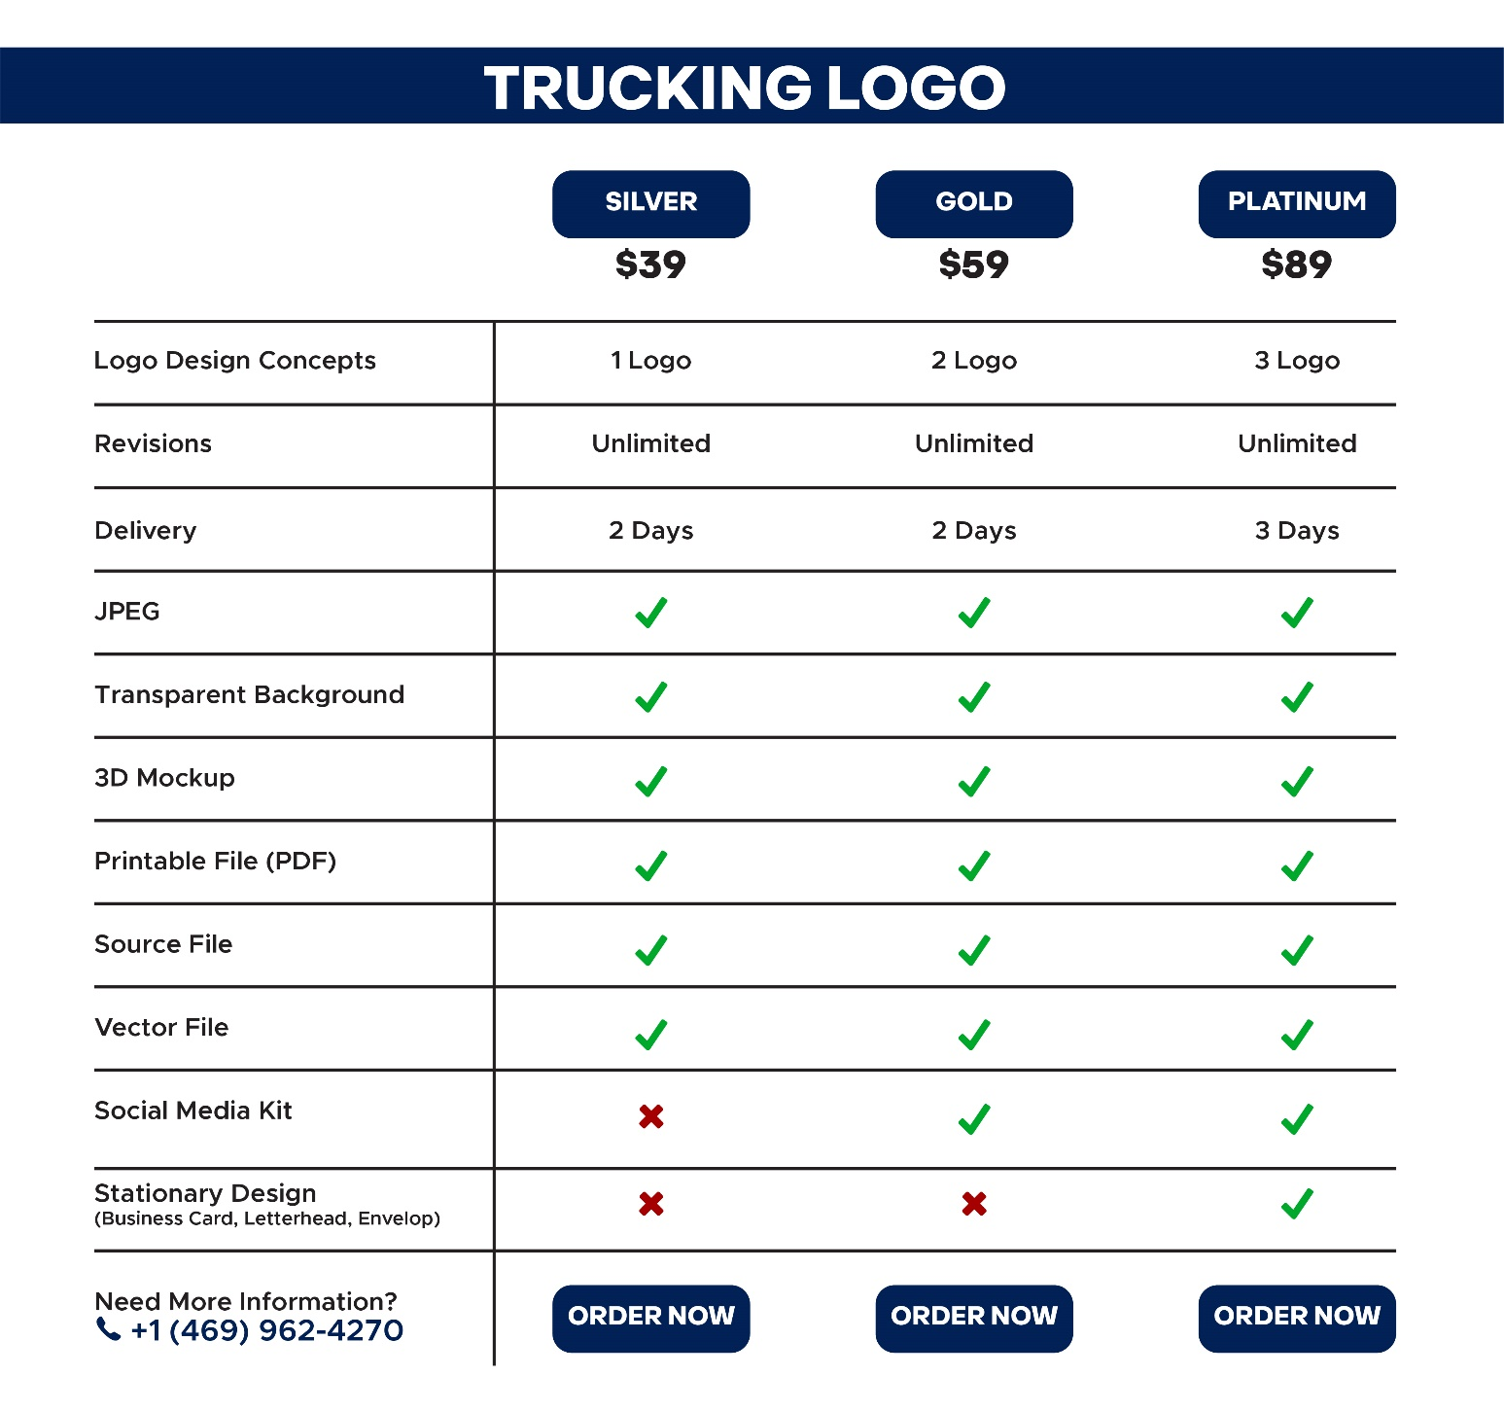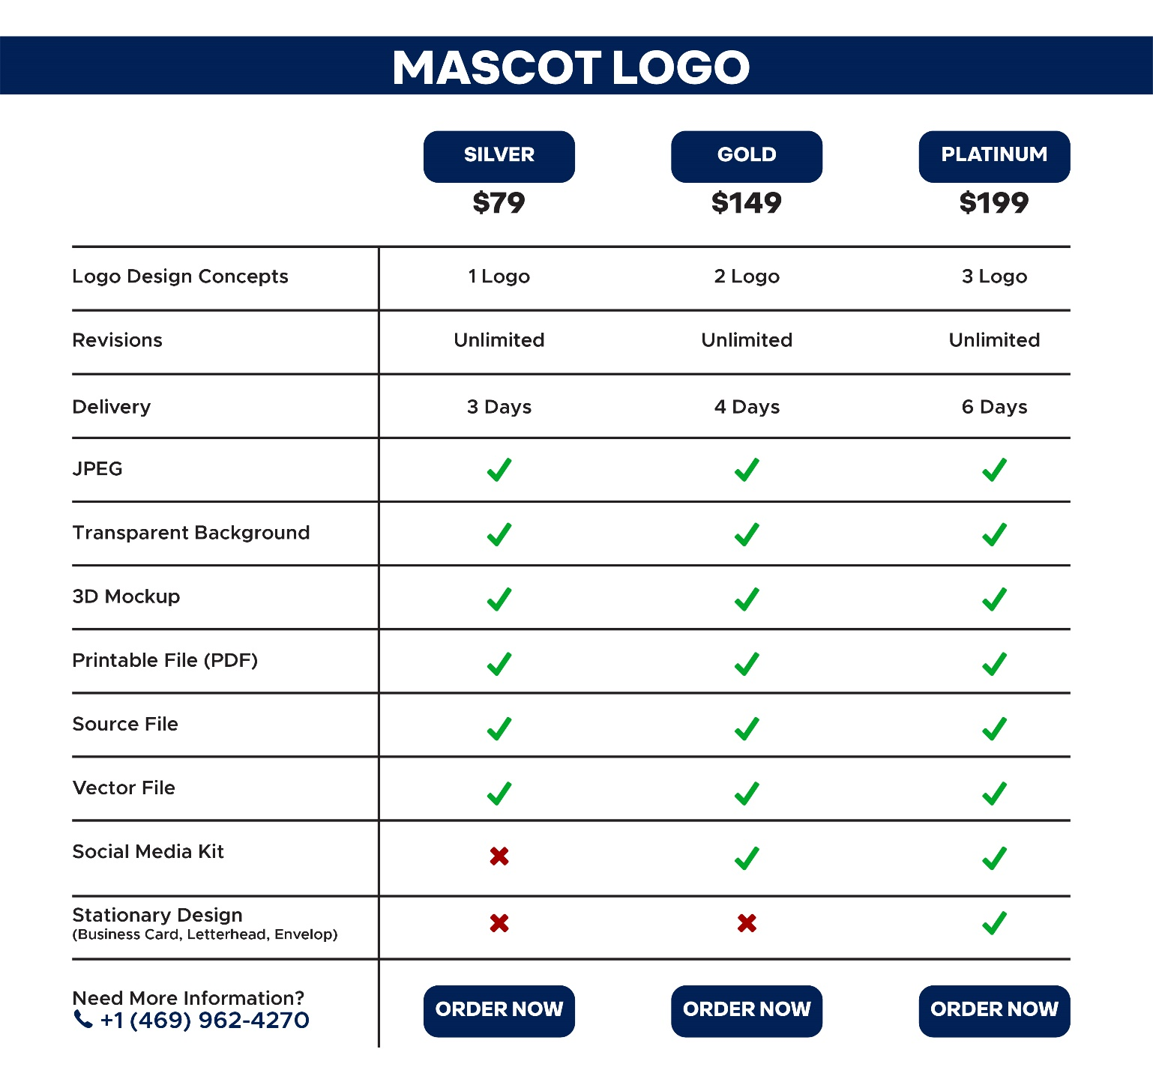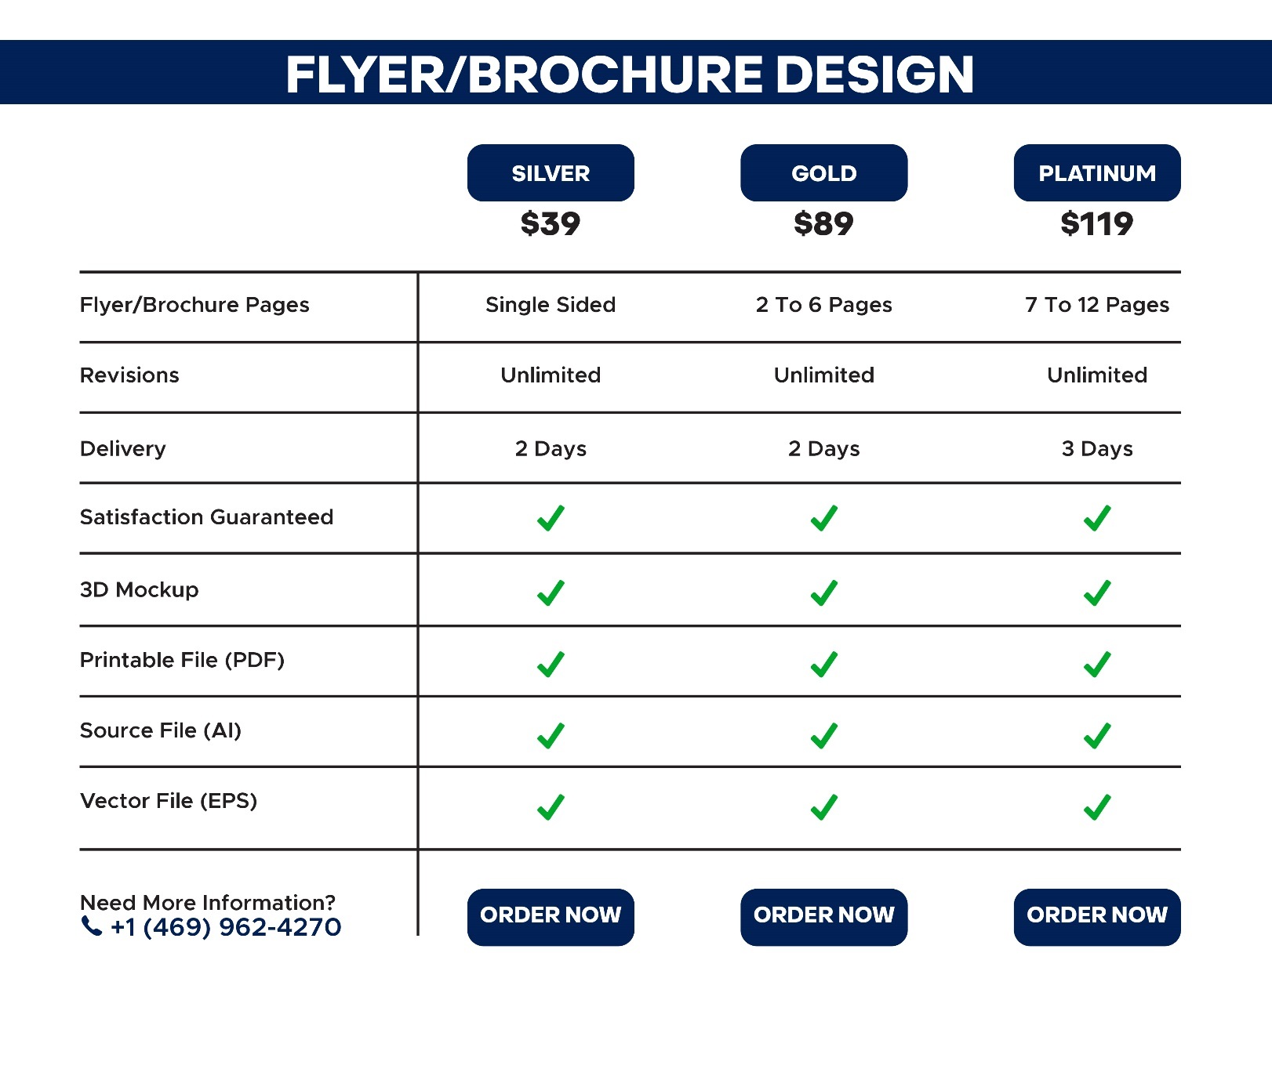

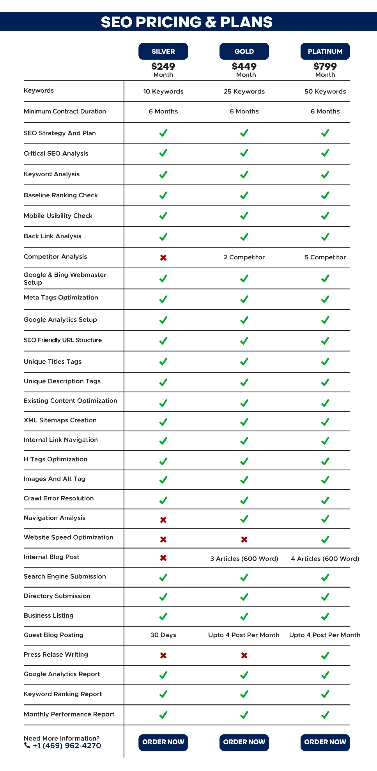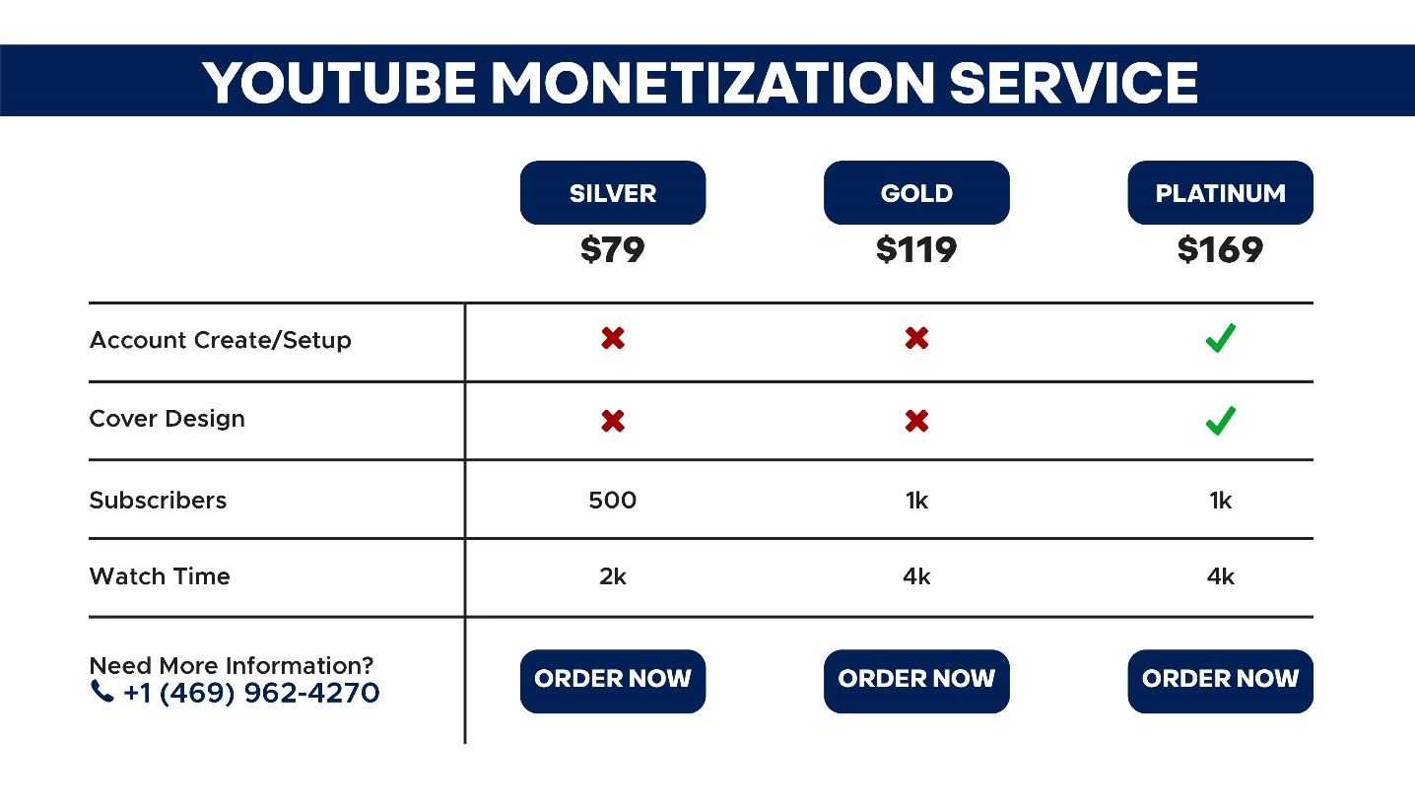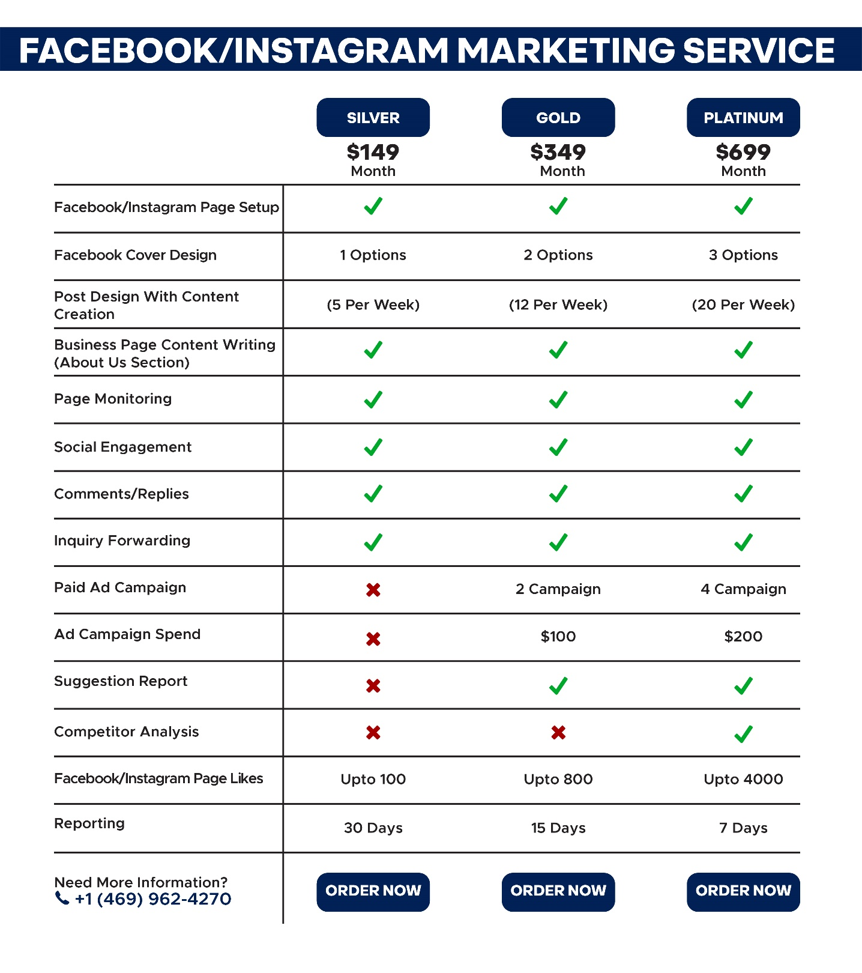

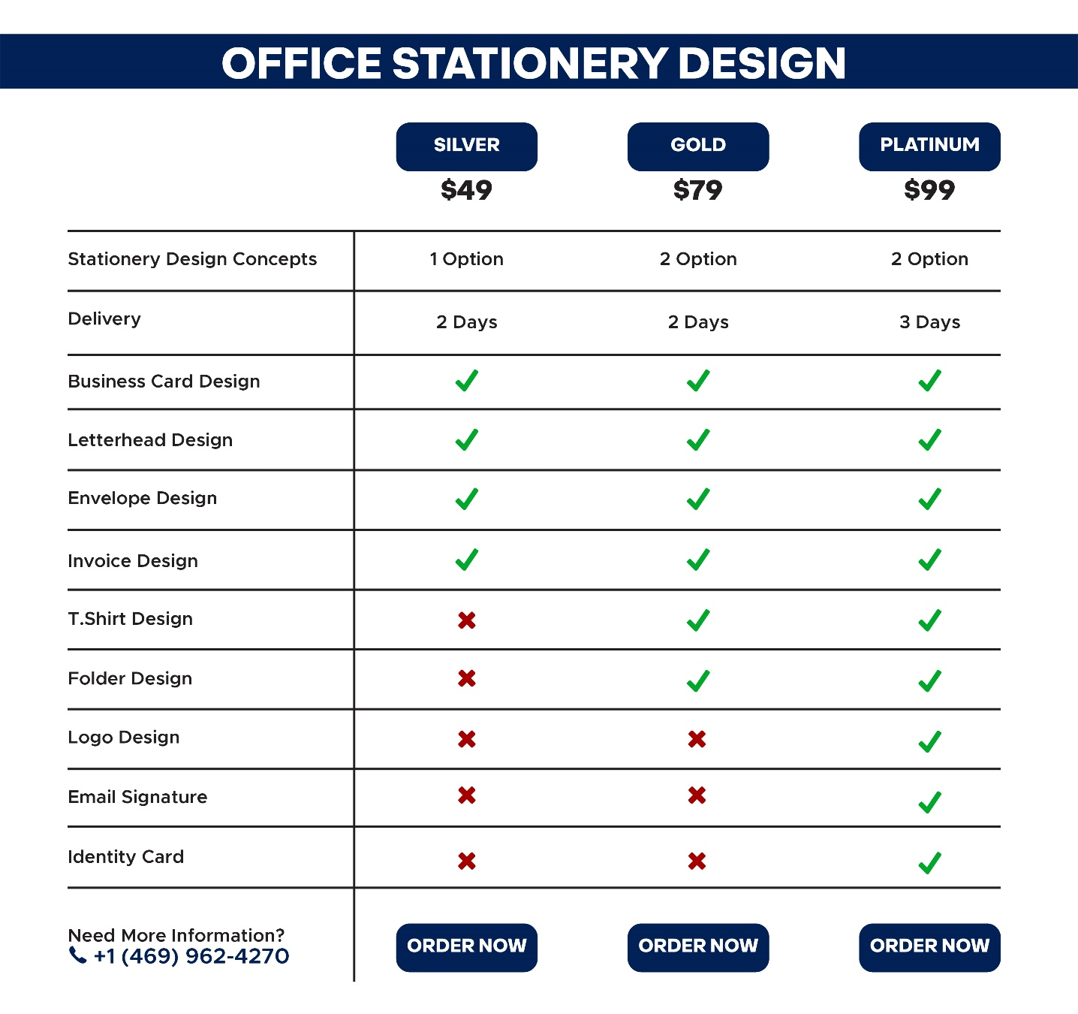

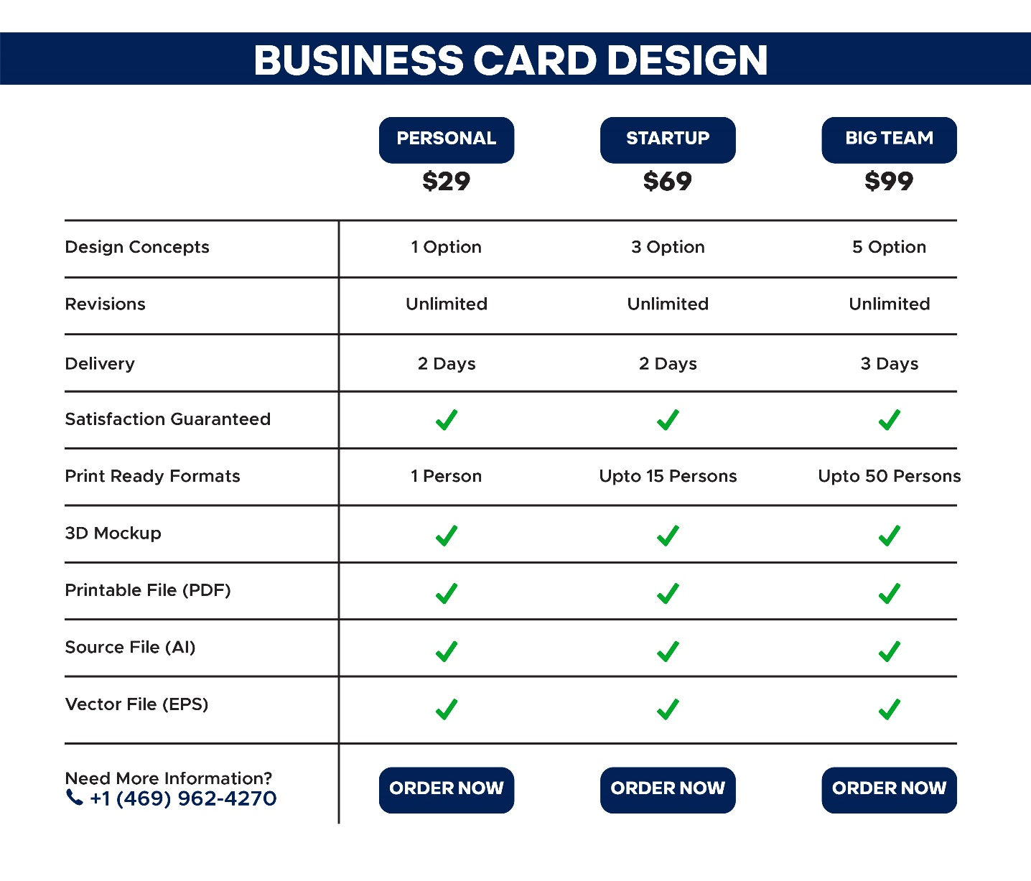

**Contact Us**

depend on you

(Also check

<https://www.damsole.com/>

<https://www.artimization.com/>

**)**

**Quote**

depend on you

(Also check

<https://www.damsole.com/>

<https://www.artimization.com/>

**Example that we liked**

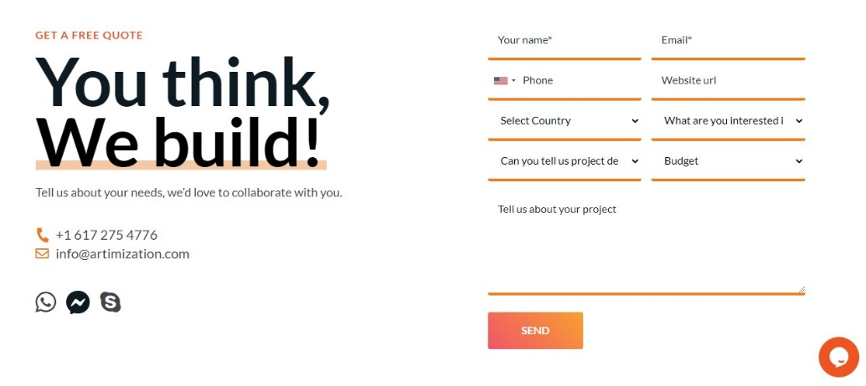

**Color Scheme and Logo**

**# 012155**

**# 8cfad0**

**# ffffff**



**Inspiration and competitor websites:**

<https://www.damsole.com/>

<https://www.artimization.com/>

**Payment Gateway/Method:**

**https://checkout.artimization.com/**

Same need this type of payment method just not add (G Pay) method

We need Bank and PayPal payment Only

Also liked this method just add Paypal in this with bank account means 2 methods show

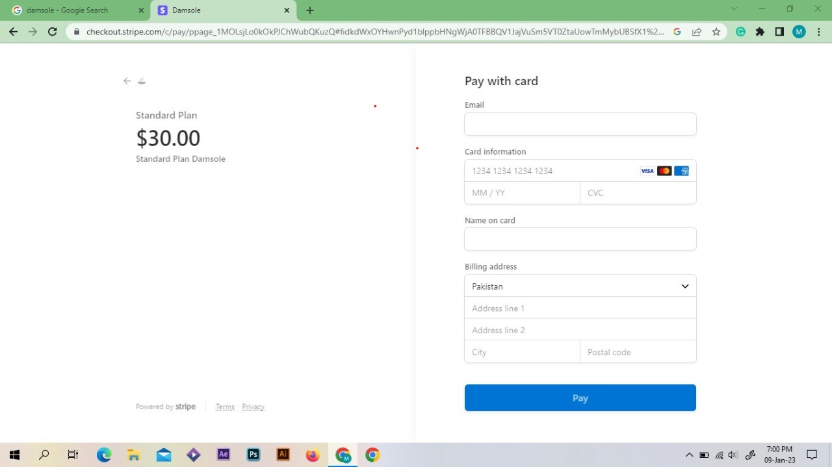

Also liked this method

This Method get from [www.freepik.com](http://www.freepik.com)

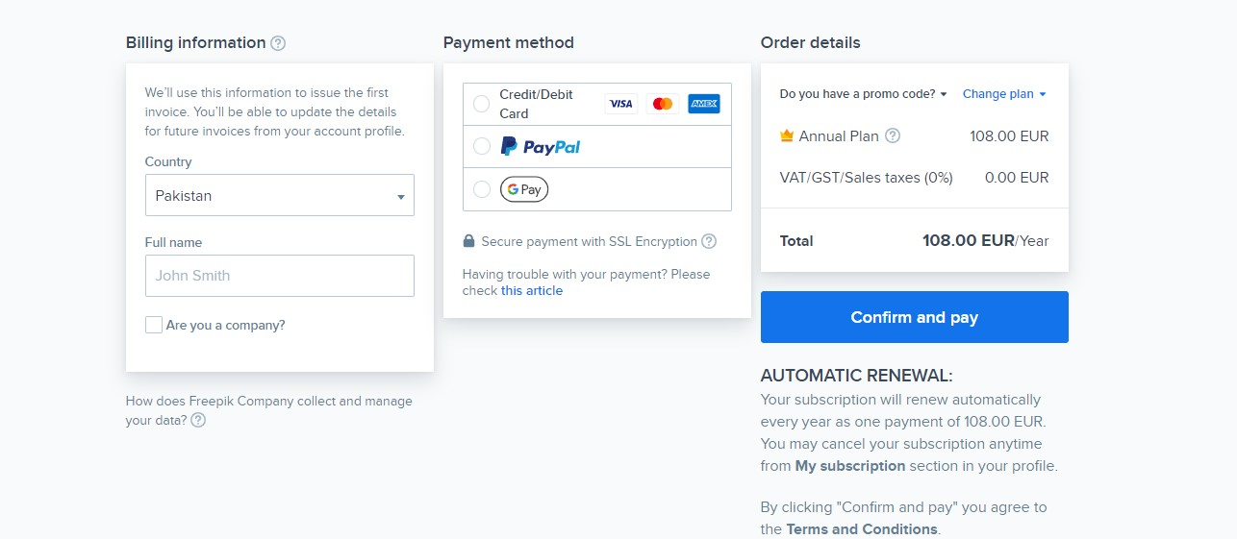

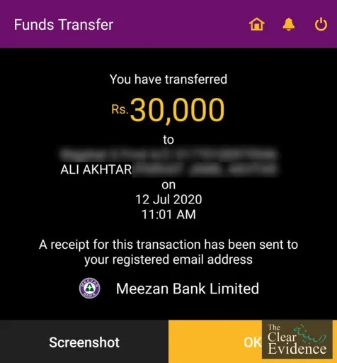

After send payment this type of invoice created in Invoice some details show like

Payment detail

Total amount

Date

Package name/detail

And written share this screenshot through us with messenger or WhatsApp

Below show two buttons

Messenger and WhatsApp

**Social Media Links:**

[**https://www.instagram.com/insraphic/**](https://www.instagram.com/insraphic/)

[**https://www.facebook.com/Insraphic**](https://www.facebook.com/Insraphic)

[**https://www.pinterest.com/insraphic/**](https://www.pinterest.com/insraphic/)

[**https://www.linkedin.com/in/insraphic/**](https://www.linkedin.com/in/insraphic/)

**Note: If you need anything else for my side, please let me know**

Thank You